**4.0 Information Gathering Process**

**4.1 Method used**

For this project, we decide to use the interactive method to collect the data required. We collected the information needed by making a questionnaire related to the problems that we identified before in the e-hailing systems. Then, we distributed the survey online across many groups and channels. We chose interactive method, specifically online questionnaire, for the gathering information process because in this project, we unfortunately don’t have the resources to do proceed with other methods.

For example, we don’t have the time to do and prepare the interview with the all the people involved in the e-hailing system (users, drivers, etc.). And we certainly also cannot do the Joint Application Design (JAD) method. Subsequently, we aren’t possible to do the unobtrusive method as well. Because, again, the lack of resources and time, we cannot use the sampling, investigation, or the observation method. Thus, we decided to proceed with the online questionnaire distribution.

Below is the list of questions in the questionnaire with its type.

|  |  |  |
| --- | --- | --- |
| **No.** | **Question(s)** | **Type of Question** |
| 1 | Ease of use | Multiple choice |
| 2 | Most complicated feature | Check box |
| 3 | Simplicity of current UI rating | Linear scale |
| 4 | Information security concern | Multiple choice |
| 5 | Misused data encounter | Multiple choice |
| 6 | Additional security features | Check box |
| 7 | Booking delay experience | Multiple choice |
| 8 | ETA accuracy | Linear scale |
| 9 | Booking difficulties during peak hours | Multiple choice |
| 10 | Improvements in efficiency | Check box |
| 11 | Overall satisfaction experience | Linear scale |
| 12 | Features to add to improve overall experience | Check box |
| 13 | Specific suggestions | Open-ended |

**4.2 Summary from method used**

After distributing the questionnaire, we successfully gathered 30 responses.

Here is the summary of each question.

* Question 1

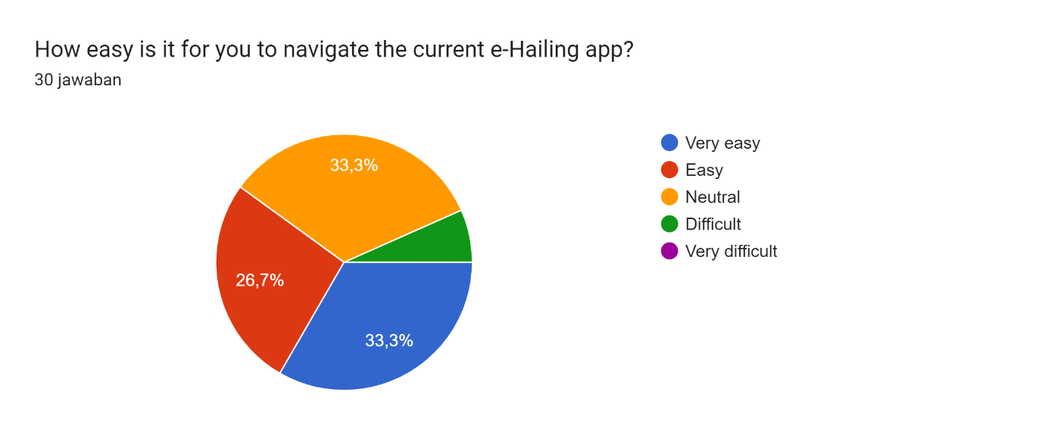

There are about 10 people that thinks the current e-hailing app are very easy to use.

* Question 2

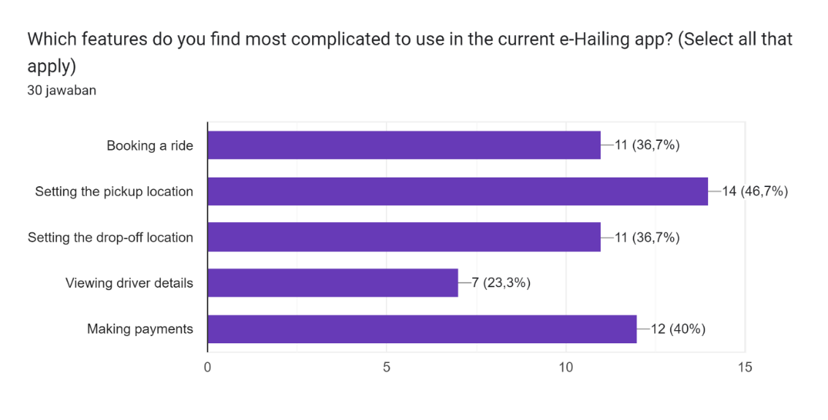

Almost half of the respondents agrees that the most complex use in the e-hailing app is setting the pickup location. Followed by making payments options.

* Question 3

Diagram jawaban Formulir. Judul pertanyaan: How would you rate the current user interface of the e-Hailing app in terms of simplicity?
. Jumlah jawaban: 30 jawaban.

Most respondents rate the current UI of the e-hailing app is average.

* Question 4

Diagram jawaban Formulir. Judul pertanyaan: How concerned are you in the security of your personal information when its being collected and stored by e-Hailing app?
. Jumlah jawaban: 30 jawaban.

About 10 out of 30 people feels normal regarding the security of personal data in the e-hailing app. While 8 of them are concerned.

* Question 5

Diagram jawaban Formulir. Judul pertanyaan: Have you ever experienced or suspected a data breach or misuse of your information when using the e-Hailing app?
. Jumlah jawaban: 30 jawaban.

14 respondents never experienced data misused in e-hailing app, but 5 of them had.

* Question 6

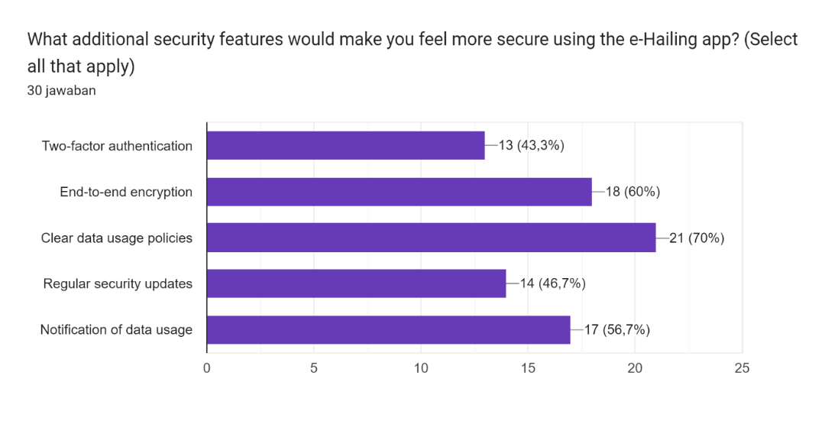

Data usage policies is the most demanded feature by more than half of the respondents, followed by end-to-end encryption and data usage notification feature.

* Question 7

Diagram jawaban Formulir. Judul pertanyaan: How often do you experience delays between booking a ride and driver pickup?
. Jumlah jawaban: 30 jawaban.

Occasionally, 15 users got some time delays between ride booking and driver pickup.

* Question 8

Diagram jawaban Formulir. Judul pertanyaan: How would you rate the accuracy of the estimated time of arrival (ETA) provided by the e-Hailing app?
. Jumlah jawaban: 30 jawaban.

Almost every respondent thinks that the ETA provided by the e-hailing app is accurate enough.

* Question 9

Diagram jawaban Formulir. Judul pertanyaan: During peak hours, how often do you experience difficulties in booking a ride?
. Jumlah jawaban: 30 jawaban.

All users had experienced difficulties in booking a ride during peak hours of e-hailing.

* Question 10

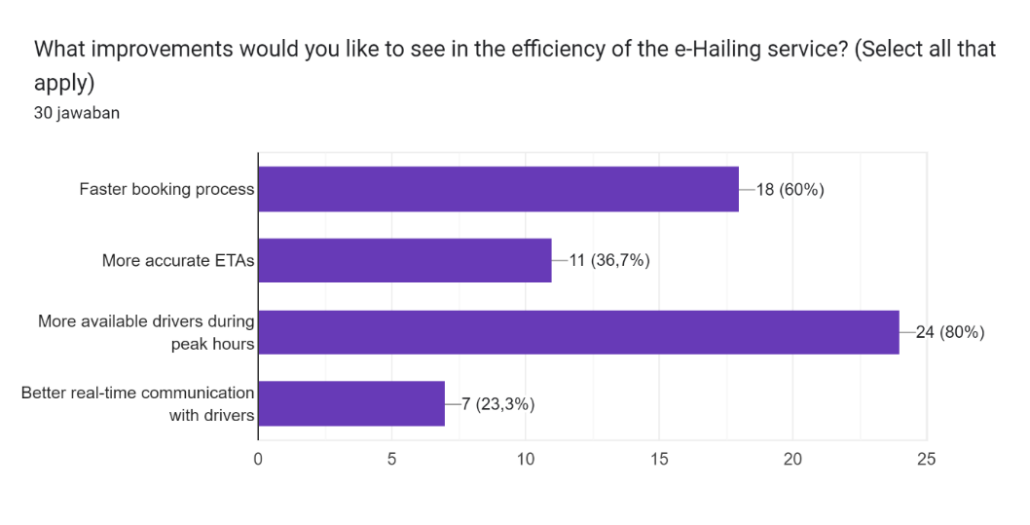

The most wanted improvement in the e-hailing system asks by users are related to drivers’ availability in peak-hours period and the booking process time.

* Question 11

Diagram jawaban Formulir. Judul pertanyaan: How satisfied are you with the overall experience of using the current e-Hailing system?
. Jumlah jawaban: 30 jawaban.

More than 90% users are satisfied with the overall of current e-hailing system.

* Question 12

Diagram jawaban Formulir. Judul pertanyaan: What features would you like to see implemented to enhance your overall experience with the e-Hailing service? (Select all that apply)
. Jumlah jawaban: 30 jawaban.

Faster response times, data security enhancements, and a simpler UI is the features that users want to improve their overall experience with the e-hailing systems.

* Question 13

Here are some other specific suggestions from the respondents.

*(This question is not compulsory to fill, so not all respondents answered it.)*